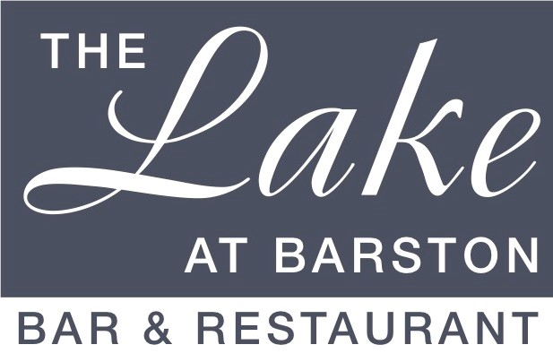

Thank you for booking one of our Dinner Shows.

Please arrive from 7.00pm, the meal will be served from 7.30pm and the entertainment will be on around 9.30pm – 9.45pm. The show lasts for around an hour depending on the act, with music and dancing and bar till 12.00am and late drinks till 1am in the spike bar & lounge.

Bar sales are by contactless payment or card only, (no cash) so please advise your guests that we no longer accept cash on the premises (apart from a gratuity).
Dress code – Smart Casual. (No caps, hoodies, trainers, tracksuits, shorts or football shirts). Fancy dress is welcome if it is considerate to others.
Please fill in the pre order form overleaf with names of all guests and return at least one week before the event. You can phone your order in on 01675 444890 or email us at admin@wmgc.co.uk Supplements should be paid for at this time, food requested on the night, may not be available

Please note that no gratuity has been included, there will be an opportunity to leave a tip on the night (Cash if possible please)

Tribute Menu 91
The ticket price of your event includes show ticket and a main course, choose from the items below, For extra choice or if any of these items are not suitable please see the additional items below which are chargeable upgrades.

Roasted Chicken Breast, Roast & New Potatoes, Vegetables and Rosemary & Red wine Jus (gf)
Broccoli & Penne Pasta Bake (v)
Spicy Ratatouille Casserole with Wild Rice (v, vg, gf)

If you do not like any of these dishes or need an alternative for dietary reasons please see the upgrade choices below.

ALTERNATIVE OPTIONS & CHARGEABLE UPGRADES

Starters
Fan of Melon with strawberries and dragonfruit (v, vg, gf) - £5
Atlantic Prawn & Crayfish Cocktail with Marie Rose (gf) - £7.50
Fried Panko crumbed Brie with an Apple & Cranberry salsa - £6.50

Main course upgrades
Steak & Ale Pie with Chips & Peas - £5
Duo of Fresh & Smoked Salmon with Potatoes, seasonal veg and Coral butter sauce - £7.50
Braised Lamb Shank with new potatoes, vegetables and minted gravy (gf) - £10
Medallions of Fillet steak with Chips, seasonal veg and Bearnaise sauce (gf) - £10
Bowl of Chips - £5

Desserts
Chocolate fudge brownie with whipped cream - £7
Lemon Cheesecake with fruits of the forest compote - £6
Fresh Fruit salad (v,vg,gf) - £6
Vanilla Ice Cream with Raspberry sauce (v, gf) - £5
Vegan Ice Cream with Mango sauce (v, vg, gf) - £5
Cheese & Biscuits (v) - £7.50

(v) – vegetarian, (vg) – vegan, (gf) – gluten free (cn) – contains nuts (other dishes may contain traces)

The Lake at Barston, West Midlands Golf Club, Marsh House Farm Lane, Barston, Solihull B92 0LB

Name of Tribute ____________________ Event Date _____________

Organisers Name _______________________ No of Guests ______________________

 |  | STARTER |  |  | MAIN |  |  |  |  |  |  |  | DESSERT
Names |  | Melon £5 | Prawns £7.50 | Brie £6.50 | CHICKEN - £0 | PASTA - £0 | CASSEROLE - £0 | Pie + £5 | Fish + £7.50 | Lamb + £10.00 | Steak +£10.00 | Chips + £3.95 | Brownie + £7 | Cheesecake £6 | Fruit Salad £6 | Ice Cream £5 | Vegan Ice Cream £5 | Cheese £7.50
1
2
3
4
5
6
7
8
9
10
11
12

(v) – vegetarian, (vg) – vegans, (gf) – gluten free diet (cn) – contains nuts (other dishes may contain traces)
If you have a dietary condition or for more information on allergens, please contact us.

Please fill in the order form (supplementary items must be paid for 1 week before the event)

Terms and Conditions

Please note that we are unable to accept requests for alternative menu items for this event, however in certain medical cases we will try our best to cater for your needs. Parties of 2 may be joined up onto larger tables. We are unable to offer refunds in the event of cancelled bookings, however if you need to cancel and can provide reasonable notice, we will try to resell your tickets and refund the value of the resold tickets to you (may be reduced to sell). Any cancellations with less than 7 days notice may not be considered.

