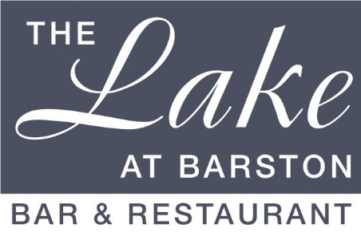
The Lake at Barston tribute nights FAQs

Where is the venue? At the West Midlands Golf Club in Barston, Solihull, B92 0LB. 01675 444890. thelakeatbarston.co.uk
How many can I book? We take bookings from 2 - 200 people, on tables up to 24
What is included? Your ticket includes a main course meal (normally Chicken with potatoes & Vegetables or Vegetarian dish or Vegan dish) the entertainment, and in house disco. A tip is not included, but there will be a tip try on your table on the night and a small cash tip would be appreciated. This is shared between all staff on duty. VAT is included in all payments.
How do I book? By phone (daylight hours) 01675 444890, or online, find the event you want to go to and there is a widget at the bottom of the page
How do I organise a big party? Book online, pay for the amount of tickets you need, then you will be sent a pre order form. You can send a link to your friends and they can order their own food and pay for there own upgrades, simple!
What is the dress code? Smart - dress to impress. We ask you not to wear trainers, caps, torn jeans or hooded tops, but you can have fun with fancy dress if considerate of other guests.
What are the timings? Arrive from 7pm, starters go out about 7.30pm, entertainment 9.30pm for 60-90 minutes depending on the act and bar & dancing till midnight and late drinks till 1am in the Lounge.
Do you take cash or card? Card or contactless payments only over the bar but staff tips in cash if possible
Can kids go? Over 14s, or at managers discretion
Do you cater for special diets? Our menus consider vegetarians, vegans, gluten free and religious requirements, so for these reasons we will not make any amendments to the menus. Sometimes you may have to change to an upgraded item if the standard items are not suitable, in this case upgrades are still chargeable.
Do you have accommodation? There are no rooms here, but there are many hotels and B&Bs local, search google for hotels near the Lake at Barston
Can I bring my own drinks? Absolutely not! We are keeping the ticket price to a minimum and our bar prices are reasonable! Anyone found with their own drinks will be asked to leave.
Do you have a taxi number? Balsall Common & Meriden Cars 01676 529222, A2B cars is on 01676 545 212, Uber are in good supply and quite often the quickest!

