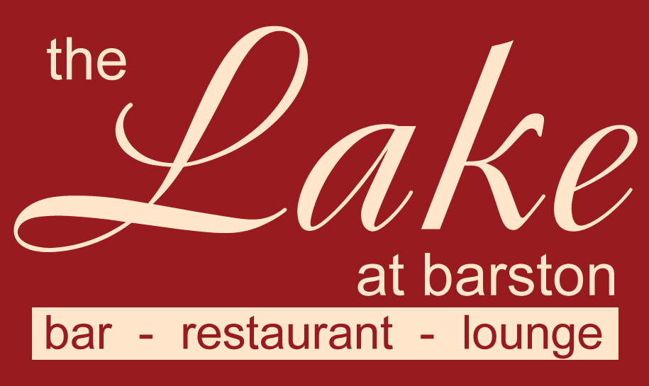
Thank you for booking one of our Dinner Shows.

Please arrive 7.00pm – 7.30pm, the meal will be served at 8.00pm and the entertainment will be from 10pm for around an hour depending on the act, with music and dancing and bar till 12.00am and late drinks till 1am in the spike bar & lounge.

Bar sales are by contactless payment or card only, (no cash) so please advise your guests that we no longer accept cash on the premises apart from a gratuity).
Dress code – Smart Casual. (No caps, hoodies, trainers, tracksuits, shorts or football shirts). Fancy dress is welcome if it is considerate to others.
Please fill in the pre order form overleaf with names of all guests and return at least one week before the event. You can phone your order in on 01675 444890 or email us at admin@wmgc.co.uk Supplements should be paid for at this time, food requested on the night, may not be available

Please note that no gratuity has been included, there will be an opportunity to leave a tip on the night (Cash if possible please)

The ticket price of £19.95 includes show ticket (£10) and a main course, choose from the items below in RED, or choose a chargeable upgrade.

Set Menu (Menu code 90A)
(v) – suitable for vegetarians, (vg) – suitable for vegans, (gf) – suitable for gluten free diet (cn) – contains nuts (other dishes may contain traces) If you have a dietary condition or for more information on allergens, please contact us.
Included with this show is MAIN COURSE ONLY, choice of;
Chicken Breast, Anna Potato, Seasonal Greens, Basil Cream Sauce (gf)
Wild Mushroom Tagliatelle, Creme Fraiche, Chives (v)
Asparagus & Spinach Risotto, Herb Oil, Vegan Parmesan Cheese (v, vg. gf)
If you do not like any of these dishes or need an alternative for dietary reasons please see the upgrade choices below.

Or you may upgrade to a supplementary dish from the choices below

CHARGEABLE EXTRAS
AVAILABLE IF PRE ORDERED
Starters
Minestrone Soup with bread roll (v,gf) £6.00
Melon Rose, Strawberry Compote (v, vg, gf, £6.00)
Prawn Cocktail, Marie Rose Sauce, Brown Bread Fingers (£7.50 supplement)
Main Courses
Grilled Salmon, Anna Potato, Seasonal Greens, White Wine & Chive Cream Sauce (£7.50 supplement)
Braised Lamb Shank, Anna Potato, Seasonal Greens, Red Wine Sauce (gf, £10.00 supplement)
Grilled Flat Iron Steak, Chips, Tomato, Mushroom, Watercress Salad (gf, £10.00 supplement)
Steak & Ale Pie, Chips, Seasonal Greens, Gravy (£5.00 supplement)
Portion of Chips (v, gf, £3.95 supplement)
Desserts
Apple Crumble Tart with custard £6.00
Vanilla Cheesecake, Blueberry Compote (v, £7.50)
Fresh Fruit Salad, Chantilly Cream (v, £7.50)
Vanilla & Strawberry Ice Cream topped with whipped cream & Raspberry sauce (v, gf, £6.00)
Cheese and Biscuits (v) (£7.50)
Please fill in the order form overleaf (supplementary items must be paid for 1 week before the event)
Please note that we are unable to accept requests for alternative menu items for this event, however in certain medical cases we will try our best to cater for your needs. Parties of 2 may be joined up onto larger tables. We are unable to offer refunds in the event of cancelled bookings, however if you need to cancel and can provide reasonable notice, we will try to resell your tickets and refund the value of the resold tickets to you (may be reduced to sell). Any cancellations with less than 7 days notice may not be considered.

The Lake at Barston Restaurant, at West Midlands Golf Club, Barston, Solihull, B92 0LB. 01675 444890

Name of Tribute ____________________ Event Date _____________

Organisers Name _______________________ No of Guests ______________________
Set Menu Dishes are in ORANGE Columns, Pink Columns are Supplementary items
 |  | STARTER |  |  | MAIN |  |  |  |  |  |  |  | DESSERT
Names |  | SOUP £6 | Melon £6 | Prawns £7.50 | CHICKEN £0.00 | Tagliatelle £0.00 | Risotto £0.00 | Fish + £7.50 | Lamb + £10.00 | Steak +£10.00 | Pie + £5 | Chips + £3.95 | Crumble + £6 | Cheesecake£7.50 | Fruit Salad £7.50 | Ice Cream £6 | Cheese £7.50
1
2
3
4
5
6
7
8
9
10
11
12
13
14
15
16
17
18
19
20

