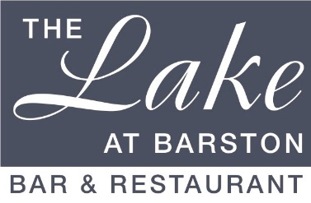
Christmas Festive Gold Menu 2024
3 courses £29.95 pp (v – vegetarian, vg – vegan, gf – gluten free, cn – contains nuts)
A pre order will be required 1 week before the event

Starters
Parsnip & Apple Soup (v, vg, gf)
Rose of Melon, with Passionfruit and Raspberry Coulis (v, vg, gf)
Button Mushrooms in a creamy Garlic & White Wine sauce (v, gf)
Baked English Brie with Cranberry & Apple Compote (v)
************
Main Courses
Roast Breast of Turkey served with Bacon wrapped Chipolata, Stuffing, Roast Potatoes, Vegetables & Gravy
Seared fillet of Salmon served with Dill Cream sauce, New Potatoes & Vegetables (gf)
Roasted Loin of Bacon served with New Potatoes, Vegetables, and Parsley sauce (gf)
Slow roasted Rump of Lamb with Mashed Potato, Minted Gravy & Vegetables (gf)
Sweet Potato & Butternut Squash Wellington with Vegan Cheese, New Potatoes & Vegetables (v, vg)
************
Desserts
Christmas Pudding with Brandy sauce (v, cn)
Classic Lemon Tart, Berry Compote (v)
Mince Pie Ice Cream Sundae (v, cn)
Fresh Fruit Salad (v, vg, gf) with pouring Cream (v, gf)

The Lake at Barston, Solihull, West Midlands 01675 444890

