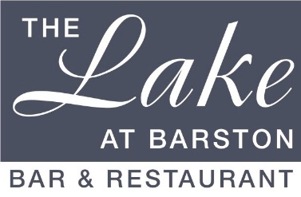

Christmas Day Lunch 2024
(v – Suitable for vegetarians, vg – Suitable for vegans, gf – gluten free, cn – contains nuts)
£85.00 per person, £45.00 for ages 8-12, £35.00 for ages 3-7.

Starters
Duo of Melon with Dragon Fruit and Champagne Sorbet (v, vg, gf)

White Onion & Cider Soup, Stilton Crouton (v, vg, gf)

Creamy Garlic Button Mushrooms and Chives with Ciabatta Bread (v) (gf bread upon request)

Atlantic Prawn Cocktail with Marie Rose sauce and King Prawn garnish (gf)

************************
From the Carvery

Breast of Turkey, Sirloin of Beef or Honey roasted Gammon.
Served with a selection of Potatoes & Vegetables from the Carvery

Vegetable, Chestnut, and Basil Crumble with Cous Cous topping (v, vg)
Served with a selection of Potatoes & Vegetables from the Carvery
(GF Nacho crumble topping available upon request)

Vegetable Lasagne Verdi (v)
Served with a selection of Potatoes & Vegetables from the Carvery

(Please order v or vg with starters)

*************************
Desserts

Christmas Pudding with Brandy sauce (v, vg, cn)

Chocolate and Cherry Brandy Terrine with a Black Cherry Compote (v)

Lemon Cheesecake with Winter Berry Compote (v)

Cheese & Biscuits (v)

Fresh Fruit Salad (v, vg, gf) with pouring Cream (v, gf)

All bookings have been pre-paid so todays bill will just be for your drinks only.
We have not included a gratuity in your pre-paid charge.

