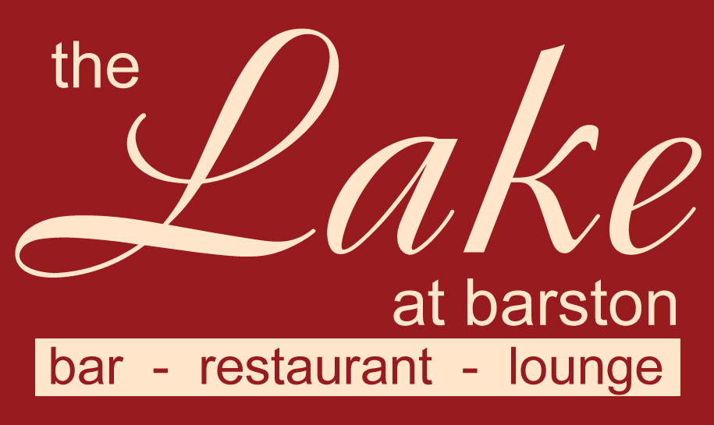
Thank you for booking one of our Dinner Shows.

Please arrive 7.00pm – 7.30pm, the meal will be served at 8.00pm and the entertainment will be from 10pm for 45 - 90 minutes depending on the act, with music and dancing until late and bar service until 1am.

Please bring a contactless card for bar purchases and advise members of your party that we no longer accept cash on the premises.
Dress code - Smart / Casual. (No caps, hoodies, trainers, tracksuits, shorts or football shirts). Fancy dress is welcome if it is considerate to others.
Please fill in the pre order form overleaf with names of all guests and return at least one week before the event. We still need notification from you even if you only require the set menu. You can phone your order in on 01675 444890 or email us at admin@wmgc.co.uk Supplements should be paid for at this time, if supplements are requested on the night, we will provide them if available, but the charge will be double the charge displayed on this menu, this is because the price shown is considering that it is replacing the set menu item.
Please note that no gratuity has been included, there will be an opportunity to leave a tip on the night (Cash if possible please)

Set Menu (Menu code 87)
(v) – suitable for vegetarians, (vg) – suitable for vegans, (gf) – suitable for gluten free diet (cn) – contains nuts (other dishes may contain traces) If you have a dietary condition or for more information on allergens, please contact us.

Tomato & Mozzarella Salad, Rocket, Pesto, Balsamic (v, cn)

Chicken Breast, Thyme Roasted New Potatoes, Roasted Courgettes, Glazed Carrots, Grain Mustard Café De Paris Sauce (gf)

Baked Vanilla Cheesecake, Strawberry & Basil Compote (v)

Or you may upgrade to a supplementary dish from the choices below
Starters
Duo of Melon with Passionfruit and Mint Syrup (v, vg, gf, no charge supplement)
Smoked Salmon & Cream Cheese Roulade, Wild Rocket, Ciabatta Grissini, Salsa Verde (£2.50 supplement)
Main Courses
Butternut, Sweet Potato & Vegan Cheese Wellington (v, vg, no charge)
Thyme Roasted New Potatoes, Roasted Courgettes, Glazed Carrots, Onion Sauce
Red Lentil & Spinach Dhal, Pilaf Rice, Onion Bhaji (v, vg, no charge gf without Bhaji)
Grilled Haddock Supreme, Roasted Fennel, New Potatoes, Mussel & Chive Broth (gf, £7.50 supplement)
Rump of Lamb, Thyme Roasted New Potatoes, Veg’s, Red Wine & Onion Sauce (gf, £10.00 supplement)
Feather blade of Beef, Thyme Roasted New Pots, Veg’s, Red Wine & Onion Sauce (gf, £10.00 supplement)
Grilled Bacon Loin Steak, Chips, Pineapple Salsa, chopped Salad (£5.00 supplement)
Portion of Chips (v, gf, £3.95 supplement)
Desserts
Strawberry Sundae, Whipped Cream, Strawberry Sauce (v, gf £2.50 supplement)
Fresh Fruit Salad, Chantilly Cream (v, £2.50 supplement)
2 scoops of Vanilla Ice Cream with Raspberry sauce (v, gf, no charge, vg if requested)
Cheese and Biscuits (v) (£5.00 supplement as 4th course)
Please fill in the order form overleaf (supplementary items must be paid for 1 week before the event)
Please note that we are unable to accept requests for alternative menu items for this event, however in certain medical cases we will try our best to cater for your needs. Parties of 2 may be joined up onto larger tables. We are unable to offer refunds in the event of cancelled bookings, however if you need to cancel and can provide reasonable notice, we will try to resell your tickets and refund the value of the resold tickets to you (may be reduced to sell). Any cancellations with less than 7 days notice may not be considered.

The Lake at Barston Restaurant, West Midlands Golf Club, Barston, Solihull, B92 0LB. 01675 444890

Name of Tribute ____________________ Event Date _____________

Organisers Name _______________________ No of Guests ______________________
Set Menu Dishes are in ORANGE Columns, Pink Columns are Supplementary items
 |  | STARTER |  |  | MAIN |  |  |  |  |  |  |  | DESSERT |  |  |  | 4th
Names |  | SALAD | Melon £0.00 | Salmon £2.50 | CHICKEN | Wellington £0.00 | Dhal £0.00 | Fish £7.50 | Lamb £10.00 | Beef £10.00 | Bacon £5.00 | Chips £3.95 | CHESECAKE | Sundae £2.50 | Fruit Salad £2.50 | Ice Cream £0.00 | Cheese £5.00
1
2
3
4
5
6
7
8
9
10
11
12
13
14
15
16
17
18
19
20

