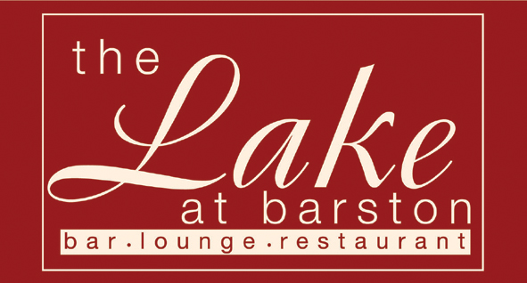

Dear Sir / Madam

Thank you for booking to come to our Ascot Ladies Day here at The Lake at Barston.
Please arrive for a Prosecco Welcome drink at 12.00pm.
The meal will be served at 1.00pm and the first race will be at 2.30pm. We will be taking bets on the day and will provide the runners and riders for you to study. We will be serving Tea & Scones at 4.30pm and the last race is at 6.10pm.
The dress code for the day is; Ladies - hats or fascinators compulsory, Gentlemen, suits or jacket & tie.

To assist the catering operation please fill in the pre order form overleaf and return at least one week before the event to ensure your preferred meal is available.

Royal Ascot Ladies Day Tuesday 20th June 2023

Starters
(v) – suitable for vegetarians, (vg) – suitable for vegans (gf) – suitable for gluten free diet (cn) – contains nuts.

Rose of Melon with Exotic Fruits and Champagne Sorbet (v,vg,gf)

Summer Vegetable Consommé (v,vg,gf)

Panko Crumbed French Brie with Apple and Cranberry Salsa (v)

Main Courses

Steam Roasted Chicken Breast with Forest Mushrooms, Parsley Mash and Summer Greens (gf)

Poached Fillet of Salmon, Shrimp sauce, Jersey Royals and Summer Greens (gf)

Malaysian Sweet Potato and Spinach Curry with Rice (v,vg,gf)

Desserts

Chocolate Fudge Brownie and Vanilla Ice Cream (v)

Fresh Fruit Salad (vg, gf) with Pouring Cream (v, gf)

Lemon Meringue Ice Cream Sundae (v, gf)

Please fill in the order form overleaf

Please note that we are unable to accept requests for alternative menu items for this event, however in certain medical cases we will try our best to cater for your needs. We are unable to offer refunds in the event of cancelled bookings, however if you need to cancel and can provide reasonable notice, we will try to resell your tickets and refund the value of the resold tickets to you (may be reduced to sell). Any cancellations with less than 7 days notice may not be considered.

The Lake at Barston Restaurant, West Midlands Golf Club, Barston, Solihull, B92 0LB. 01675 444890 – www.thelakeatbarston.co.uk

Ascot Race Day – 20th June 2023

Organisers Name ___________________________________ No of Guests _________________________

 |  | 1st Course |  |  | 2nd Course |  |  |  |  | 3rd Course
Name (all names please) |  | Melon | Consommé | Brie |  | Chicken | Salmon | Curry |  | Brownie | Fruit Salad | Sundae
1
2
3
4
5
6
7
8
9
10
11
12
13
14
15
16
17
18

