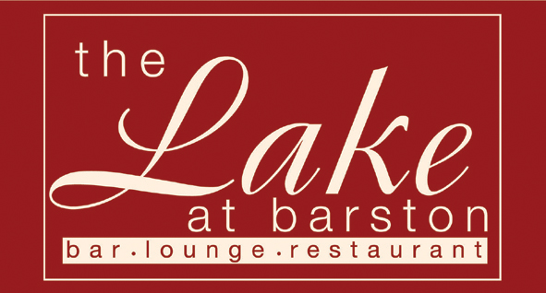
Dear Sir / Madam

Thank you for booking to come to our New Years Eve party here at The Lake at Barston Restaurant. The meal will be served at 8.00pm so please arrive between 7.00pm and 7.30pm. The Bar will be closed at 1.00am, and we advise that you have your transport home organised well in advance. The dress code for the evening is Smart Casual or Lounge suits. Dinner jackets are welcome, please, no T-Shirts, Blue Jeans or Trainers.

Terms & Conditions
1. The management reserves the right to refuse entry or request any person to leave without prior notice or providing reason. 2. Anyone found to have brought in drinks purchased off the premises or anyone behaving in an unacceptable manner, which may cause danger or offense to others, will be asked to leave immediately. 3. We are unable to offer refunds in the event of cancelled bookings, however if you need to cancel the whole party and can provide reasonable notice, we will resell your tickets if they are requested, and refund the value of the resold tickets to you 4. We may offer any unsold tickets at a reduced rate at short notice. 5. Any non-arrivals or cancellations with less than 7 days’ notice may not be considered. 6. By returning this menu, you are deemed to have read, and accept these Terms & Conditions and that you will inform your guests as necessary.
New Year’s Eve Menu 2022
(v – suitable for vegetarians, gf – suitable for gluten free diets, cn contains nuts or may do)
Starters
Seafood Platter; Prawns, Crayfish, Smoked Salmon and fresh Oyster with Salad, Marie Rose (gf)

Creamy Garlic Wild Mushrooms with Ciabatta (v)

Rose of Melon with exotic Fruits and Champagne Sorbet (v, vg, gf)

****************
Mains
Roasted Breast of Barbary Duck with a Black Cherry sauce,
Winter Greens and Lyonnaise Potatoes (gf)

Individual Fillet of Beef Wellington
with Madeira Jus, Winter Greens, and Lyonnaise Potatoes

Fresh Fillet of Salmon served on a bed of crispy Cos Lettuce
Golden Beetroot, Jersey Royal Potatoes and Caesar dressing (gf)

Malaysian spiced Vegetable and Sweet Potato Crumble,
with Chinese crisp Salad (v, vg)

****************
Desserts
White Chocolate dome filled with Raspberry Mousse, hot Dark Chocolate sauce (gf)

Passionfruit Cheesecake and Mango Coulis (v)

Exotic Fresh Fruit Salad (v,vg,gf) with Clotted Cream (v,gf)

Cheese & Biscuits (v)

The Lake at Barston Restaurant, West Midlands Golf Club, Barston, Solihull, B92 0LB. 01675 444890 – www.thelakeatbarston.co.uk
To assist the catering operation please fill in the pre order form overleaf and return at least one week before the event to ensure your preferred meal is available, along with payment for any supplements ordered. If you do not return this form you may be served last and we may not be able to give you your preferred meal. Please note that we are unable to accept requests for alternative menu items for this event, we have provided gluten free (g) and vegetarian (v) choices for people with medical needs but for rarer medical cases please call and ask for the Manager and we will try our best to cater for your needs.

New Year’s Eve 31st December 2022 – Soundations

Organisers Name ___________________________________ No of Guests ______________

Name (all names please) | Seafood | Mushrooms | Melon | Duck | Beef | Fish | Vegetarian (v) | Chocolate | Cheesecake | Cheese | Fruit Salad
1
2
3
4
5
6
7
8
9
10
11
12

