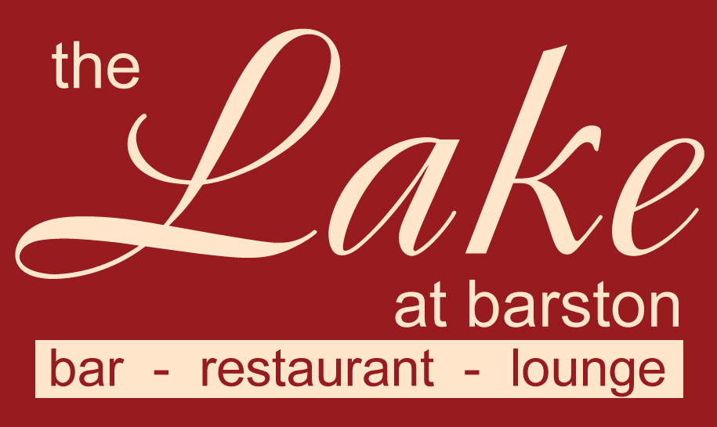
Thank you for booking one of our Dinner Shows.

Please arrive 7.00pm – 7.30pm, the meal will be served at 8.00pm and the entertainment will be from 10pm for 45 - 90 minutes depending on the act, with in house disco and bar service till 1.00am. Please check the current COVID regulations on gov.uk and on our website or on your booking confirmation letter.

Please bring a contactless card for bar purchases and advise members of your party that we no longer accept cash on the premises.
Dress code - Smart / Casual. (No caps, hoodies, trainers, tracksuits, shorts or football shirts). Fancy dress is welcome if it is considerate to others.
Please fill in the pre order form overleaf with names of all guests and return at least one week before the event. We still need notification from you even if you only require the set menu. You can phone your order in on 01675 444890 or email us at admin@wmgc.co.uk Supplements should be paid for at this time, if supplements are requested on the night, we will provide them if available, but the charge will be double the charge displayed on this menu, this is because the price shown is considering that it is replacing the set menu item.
Please note that no gratuity has been included, there will be an opportunity to leave a tip on the night (Cash if possible please)

Set Menu (Menu code 73)
(v) – suitable for vegetarians, (vg) – suitable for vegans, (gf) – suitable for gluten free diet (cn) – contains nuts (other dishes may contain traces) If you have a dietary condition or for more information on allergens, please contact us.

Rose of Melon with Orange and Strawberries (v, vg, gf)

Steam Roasted Chicken Breast with a Chasseur sauce, Potatoes and Vegetables (gf)

Classic Lemon Tart and Raspberries (v)

Or you may upgrade to a supplementary dish from the choices below

Starters
Panko crumbed Brie with an Apple & Cranberry Salsa (v, £2.50 supplement)
Chinese Duck Spring Rolls with Sweet Chilli sauce ( £2.50 supplement)
Main Courses
Goats Cheese and Ale Chutney Wellington, Tarragon Cream sauce, Potatoes and Veg’s (v, no charge)
Spicy Mediterranean Vegetable Casserole with Rice (v, vg, gf, no charge)
Seared Salmon Supreme, Shrimp sauce, Vegetables and New Potatoes (gf, £5.00 supplement)
Lamb Shank with Minted Jus, Pomme Puree and Vegetables (gf, £7.50 supplement)
Medallions of Beef Fillet (med), Chips, Vegetables, Brandy and Mushroom sauce (gf, £7.50 supplement)
10oz Sirloin Steak (med), Chips, Mushroom, Veg’s, Brandy Mushroom sauce (gf, £7.50 supplement)
Portion of Chips (v, gf, £2.50 supplement)
Desserts
Chocolate Orange Torte and Baileys Cream (v, £2.50 supplement)
Eton Mess Ice Cream Sundae (v, £2.50 supplement)
2 scoops of Vanilla Ice Cream with Raspberry sauce (v, gf, no charge, vg if requested)
Cheese and Biscuits (v) (£2.50 supplement or £5.00 if required as 4th course)
Please fill in the order form overleaf (supplementary items must be paid for 1 week before the event)
Please note that we are unable to accept requests for alternative menu items for this event, however in certain medical cases we will try our best to cater for your needs. Parties of 2 may be joined up onto larger tables. We are unable to offer refunds in the event of cancelled bookings, however if you need to cancel and can provide reasonable notice, we will try to resell your tickets and refund the value of the resold tickets to you (may be reduced to sell). Any cancellations with less than 7 days notice may not be considered.

The Lake at Barston Restaurant, West Midlands Golf Club, Barston, Solihull, B92 0LB. 01675 444890

Name of Tribute ____________________ Event Date _____________

Organisers Name _______________________ No of Guests ______________________
Set Menu Dishes are in ORANGE Columns, Pink Columns are Supplementary items
 |  | STARTER |  |  | MAIN |  |  |  |  |  |  |  | DESSERT |  |  |  |  | 4th
Names  Please list all names with contact phone number for track & trace, to save time on the night. |  | MELON | Brie £2.50 | Spring Rolls £2.50 | CHICKEN | Wellington £0.00 | Casserole £0.00 | Fish £5.00 | Lamb £7.50 | Fillet £7.50 | Sirloin £7.50 | Chips £2.50 | LEMON TART | Torte £2.50 | Sundae £2.50 | Ice Cream £0.00 | Cheese £2.50 | Cheese £5.00
1
2
3
4
5
6
7
8
9
10
11
12
13
14
15
16
17
18
19
20

